CHAPTER 6
SOFTWARE DETAILS OF THE PROJECT
6.1 ARDUINO IDE
The Arduino Integrated Development Environment - or Arduino Software (IDE) - contains a text editor for writing code, a message area, a text console, a toolbar with buttons for common functions and a series of menus. It connects to the Arduino hardware to upload programs and communicate with them.
The Arduino IDE is incredibly minimalistic, yet it provides a near-complete environment for most Arduino-based projects. The top menu bar has the standard options, including “File” (new, load save, etc.), “Edit” (font, copy, paste, etc.), “Sketch” (for compiling and programming), “Tools” (useful options for testing projects), and “Help”. The middle section of the IDE is a simple text editor that where you can enter the program code. The bottom section of the IDE is dedicated to an output window that is used to see the status of the compilation, how much memory has been used, any errors that were found in the program, and various other useful messages.
Projects made using the Arduino are called sketches, and such sketches are usually written in a cut-down version of C++ (a number of C++ features are not included). Because programming a microcontroller is somewhat different from programming a computer, there are a number of device-specific libraries (e.g., changing pin modes, output data on pins, reading analog values, and timers). This sometimes confuses users who think Arduino is programmed in an “Arduino language.” However, the Arduino is, in fact, programmed in C++. It just uses unique libraries for the device.
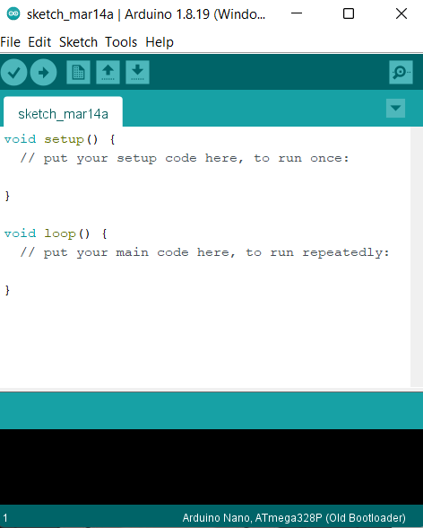
The Arduino IDE in its default state

The 6 Buttons

While more advanced projects will take advantage of the built-in tools in the IDE, most projects will rely on the six buttons found below the menu bar.

The button bar
- The check mark is used to verify your code. Click this once you have written your code.
- The arrow uploads your code to the Arduino to run.
- The dotted paper will create a new file.
- The upward arrow is used to open an existing Arduino project.
- The downward arrow is used to save the current file.
- The far-right button is a serial monitor, which is useful for sending data from the Arduino to the PC for debugging purposes.

There are plenty of other features available to consider on the IDE. But, having used many different types of microcontrollers and having been involved in multiple programming environments, it is shocking how simple the Arduino and its IDE is! In less than two minutes, you can get a simple C++ program uploaded onto the Arduino and have it running.

6.2 C++ PROGRAMMING LANGUAGE
C++ is a general-purpose programming language created by Bjarne Stroustrup as an extension of the C programming language, or "C with Classes". The language has expanded significantly over time, and modern C++ now has object-oriented, generic, and functional features in addition to facilities for low-level memory manipulation.

It is almost always implemented as a compiled language, and many vendors provide C++ compilers, including the Free Software Foundation, LLVM, Microsoft, Intel, Oracle, and IBM, so it is available on many platforms.

C++ was designed with an orientation toward systems programming and embedded, resource-constrained software and large systems, with performance, efficiency, and flexibility of use as its design highlights.

C++ has also been found useful in many other contexts, with key strengths being software infrastructure and resource-constrained applications, including desktop applications, video games, servers (e.g. e-commerce, web search, or databases), and performance-critical applications (e.g. telephone switches or space probes).
C++ is standardized by the International Organization for Standardization (ISO), with the latest standard version ratified and published by ISO in December 2020 as ISO/IEC 14882:2020 (informally known as C++20). The C++ programming language was initially standardized in 1998 as ISO/IEC 14882:1998, which was then amended by the C++03, C++11, C++14, and C++17 standards.

The current C++20 standard supersedes these with new features and an enlarged standard library. Before the initial standardization in 1998, C++ was developed by Danish computer scientist Bjarne Stroustrup at Bell Labs since 1979 as an extension of the C language; he wanted an efficient and flexible language similar to C that also provided high-level features for program organization. Since 2012, C++ has been on a three-year release schedule with C++23 as the next planned standard.


Fig. 6.1: The C++ PROGRAMMING LANGUAGE

About C++ Programming
- Multi-paradigm Language - C++ supports at least seven different styles of programming. Developers can choose any of the styles.

- General Purpose Language - You can use C++ to develop games, desktop apps, operating systems, and so on.

- Speed - Like C programming, the performance of optimized C++ code is exceptional.

- Object-oriented - C++ allows you to divide complex problems into smaller sets by using objects.

WHY C++?
- C++ is used to develop games, desktop apps, operating systems, browsers, and so on because of its performance.
- After learning C++, it will be much easier to learn other programming languages like Java, Python, etc.
- C++ helps you to understand the internal architecture of a computer, how computer stores and retrieves information.
- C++ has a large community that supports it by providing online courses and lectures, both paid and unpaid. Statistically speaking, C++ is the 6th most used and followed tag on Stack Overflow and GitHub.
- Scalability refers to the ability of a program to scale. It means that the C++ program is capable of running on a small scale as well as a large scale of data. We can also build applications that are resource intensive.

6.3 FLOW CHART
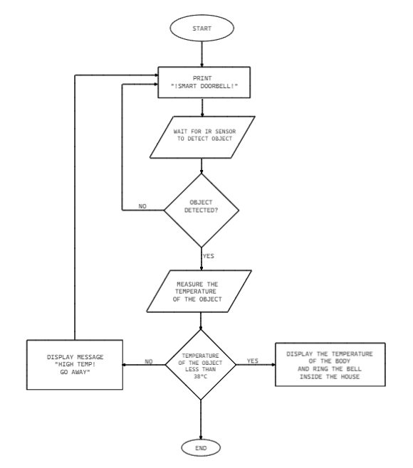
Fig. 6.2 Flow chart
6.4 CODING OF THE PROJECT
To continue with the coding part of the project, we need to install a library called as ADAFRUIT library on ARDUINO IDE to use MLX90614 temperature sensor and SSD1306 OLED display.

How to install ADAFRIUT library on ARDUINO IDE
- First of all, you need to ARUDINO IDE from the official website or from the Microsoft store.
- After finishing installation, open up the IDE. A blank document will be opened. Give it a name and save in your desired folder.
- Then, go to “Tools” section and find option called as “Manage libraries”.
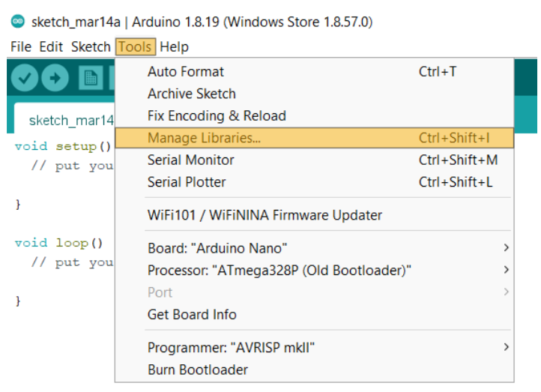

- Now a dialog box will appear. In the search bar type “Adafruit_MLX90614”.
- Select the latest version(2.1.2) and click on install button.

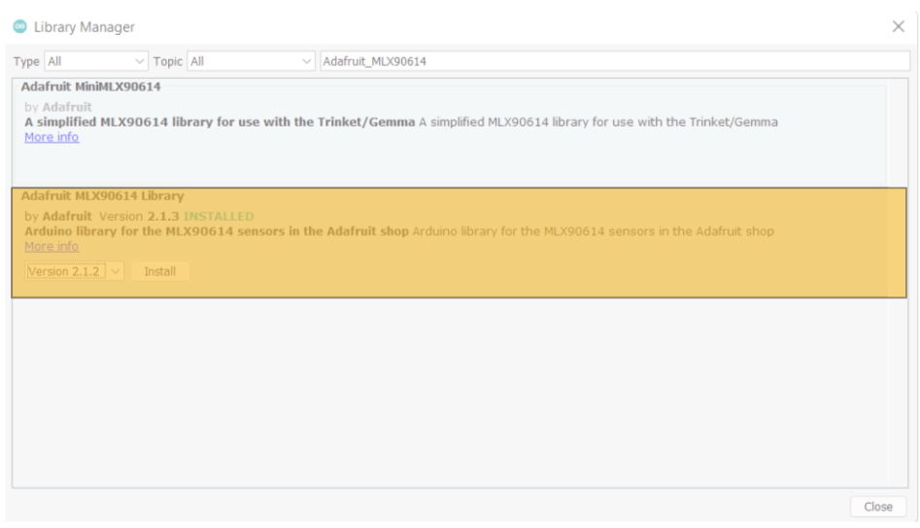
- Now, install library for OLED display by following same method but type “Adafruit_SSD1306”.
- After installing the requried libraries, now head over to the “Tools” section again and make sure you’ve selected ARDUINO NANO from the list in the “Board” section and “ATmega 328P(Old Bootloader) in the “Processor” section.
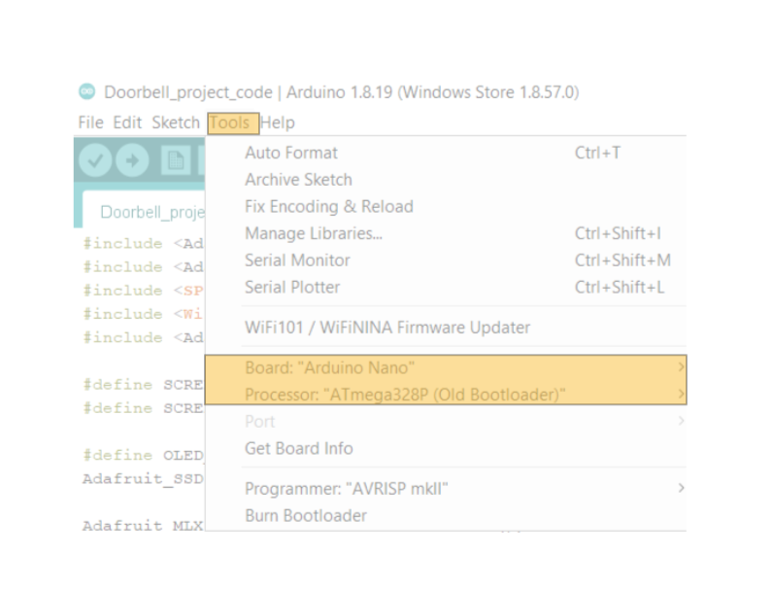
- Now, type the following code:
#include <Adafruit_MLX90614.h> //Library for MLX90614 temperature sensor
#include <Adafruit_SSD1306.h> //Library for SSD1306 OLED display
#include <SPI.h> //Library used for communicating with peripheral devices
#include <Wire.h> //Library used for communicating with I2C devices
#include <Adafruit_GFX.h>

#define SCREEN_WIDTH 128
#define SCREEN_HEIGHT 32

#define OLED_RESET 4
Adafruit_SSD1306 display(SCREEN_WIDTH,SCREEN_HEIGHT,&Wire, OLED_RESET); //Initialising the OLED display

Adafruit_MLX90614 mlx = Adafruit_MLX90614(); //Initialising the temperature sensor

#define ir 8
#define relay 3

void setup(){

pinMode(ir,INPUT);
pinMode(relay, OUTPUT);

mlx.begin();
display.begin(SSD1306_SWITCHCAPVCC, 0x3C); //Initialising the OLED display
display.clearDisplay(); //clears the OLED display
display.setTextSize(2); //Sets text size
display.setTextColor(WHITE); //sets text color
display.setCursor(0,0); //Sets cursor to first row first column
display.print(" SMART DOORBELL");
display.display(); //this function is used for the changes to make effect
}

void loop(){
delay(500); //delay of 500 milliseconds
if(digitalRead(ir) == LOW){ //IR sensor will output 0 or LOW if it detects any object
float temp = mlx.readObjectTempC() + 4; //temp variable stores temperature
if(temp <= 38) {
display.clearDisplay();
display.setCursor(0,0);
display.print("Temp:");display.print(temp);display.print(" !WELCOME!"); //Prints temperature and welcomes user if the perso has normal body temperature
display.display();
digitalWrite(relay,HIGH); //Triggers relay to ring door bell
} else{
digitalWrite(relay, LOW);
display.clearDisplay();
display.setCursor(0,0);
display.print("HIGH TEMP! GO AWAY!"); //Turns off the relay which does not ring the bell and tells person to go away due to high temperature
display.display();
}
} else { //If the IR sensor does not detect anything
digitalWrite(relay,LOW);
display.clearDisplay();
display.setCursor(0,0);
display.print(" SMART DOORBELL"); //Just prints
display.display();
}

}
- Now, click on Verify and after successful verification, click on Upload.
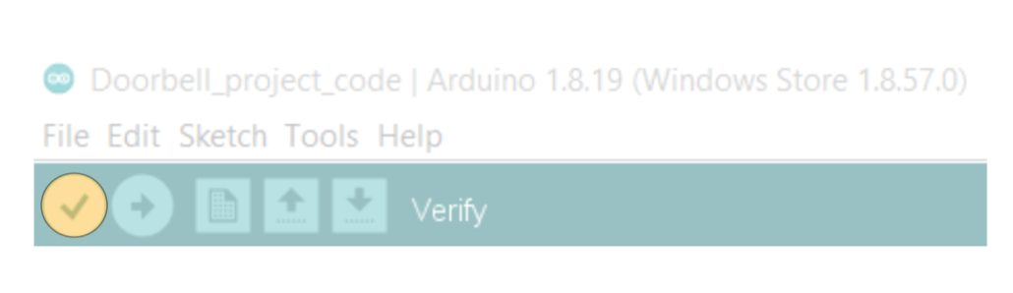put fig name Verify
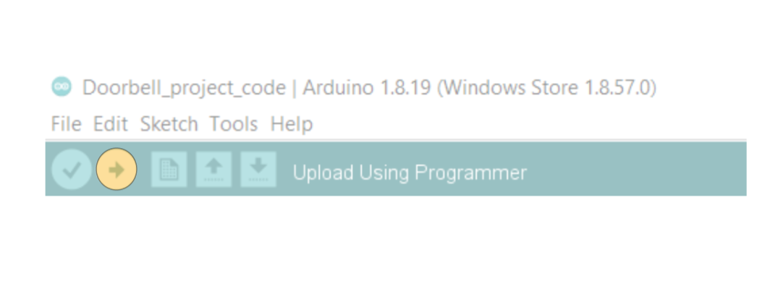
Put fig name Upload
- After uploading is done, you are now ready to test doorbell and check results.

CHAPTER 7
RESULTS AND IMPLEMENTATION

7.1 Case 1:
If the measured temperature of the object is less than or equal to the defined temperature, then the following message will be printed on the screen.

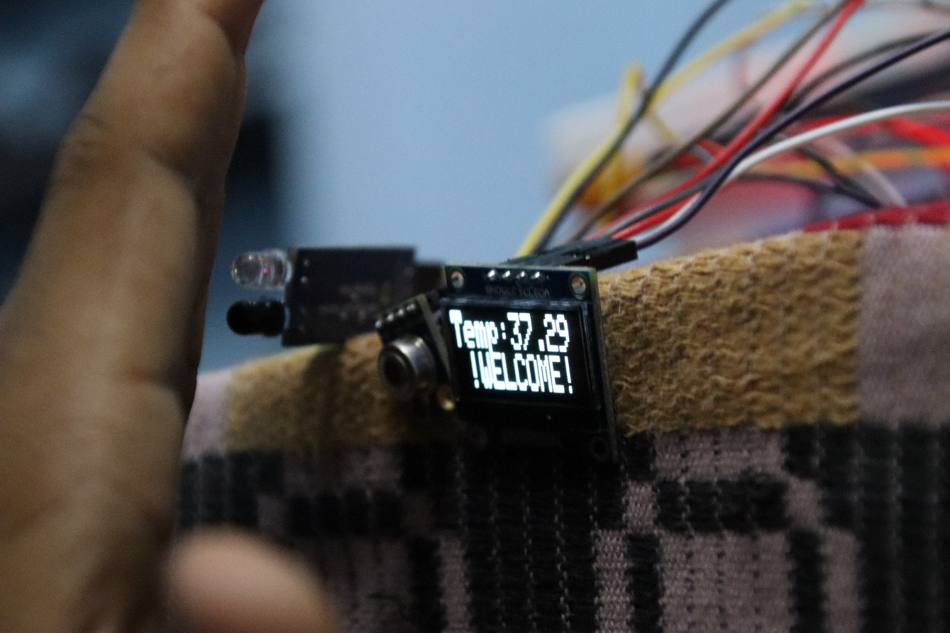

7.2 Case 2:
If the measured temperature of the object is greater to the defined temperature, then the following message will be printed on the screen.

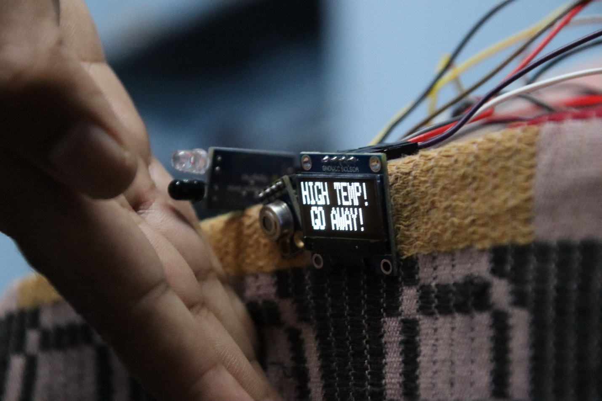

CHAPTER 8
CONCLUSION
8.1 CONCLUSION
This research can be further extended by linking it to devices through IOT. This will help in reducing the manpower to check the temperature. In the future aspect it can connect to the emergency medical services. In general, this product will provide an extra layer of safety from COVID-19 infection by making automatic decisions through the developed system as there is potential chance of new variants of COVID may arise in the coming days, the process of primary detection of temperature is very important. This can be easily done by this automated doorbell.

8.2 FUTURE SCOPE
The ARDUINO is a trivial and compact processor which is having high computing power contrary to its size. ARDUINO has its own impact for its computing, processing speed and multiple functions which can be used to program and to interface manifold devices in the real time and it is précised by the C++ programming language which is simple, highly efficient, powerful and optimal. Subsequently ARDUINO can be appropriate for the high compatible, reliable and scalable purpose in numerous applications. This type of doorbell system has an immense impact in the busy human lifestyle to simplify their efforts to keep them and their away from a deadly disease like COVID-19 through this optimal solution.
REFERENCES

PUBLICATIONS

